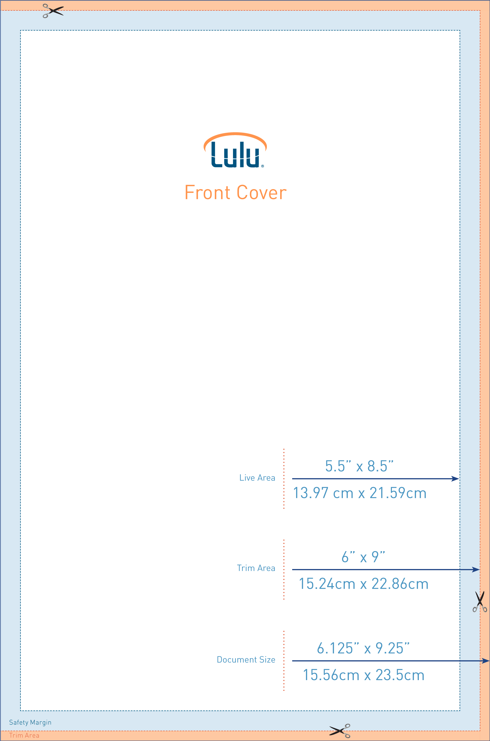

### Cover Image Templates

The Orange area (Bleed) will be trimmed from the cover. Book cover graphics should extend through this area. Text and important images should NOT extend into this area.

The Blue area (Margin) is outside of the safe zone. Make sure text (title, author, description, ISBN) does not extend into this area. It could be trimmed from the cover during the printing process.

The White, center area is the safe zone. Place what you want here and be confident it will display, in its entirety, when your book prints.

|  |  |
| --- | --- |
| Using the Cover Image Templates  1. Open the PNG Cover image template using the image-editing program of your choice. 2. Add a new layer to the image. Make sure to NOT move the template layer. Lock the template layer in place if possible. 3. Create your cover within this new layer. 4. Make sure to keep important text and images out of the blue and orange areas. This includes the placement of the barcode on the back cover. 5. When your design is complete, turn off visibility for the PNG Cover image template layer. 6. Save your file as a PNG, JPG, or GIF (PNG is suggested). 7. Your cover is now ready to upload to the Lulu publishing wizard cover designer. | Using the Print Book Template The template zip file includes a blank template with properly set margins, gutters, and MS Word styles. A style guide is also included, which provides formatting information for your book’s interior pages such as header and footer settings, use of Microsoft Word styles, standardized page numbering, and proper placement of common front and back matter sections.  Instructional text within each section of the style guide will assist you in creating a professionally formatted book. Yellow tip boxes also provide helpful tips for formatting your manuscript.  Please note the included template is not designed for full bleed printing. |

### Additional Information

If you are making a one-piece cover PDF, the required dimensions for your project will be displayed in the **One-Piece Cover** section of the **Cover Designer**. For more information, see *What Dimensions Should My One-Piece (Wraparound) Cover Have?* (link: <http://alturl.com/2w2j6>)

Properly formatting your book is as important as good grammar. Make sure your book looks its best by reading through our *Tips for Formatting MS Word Documents*. (link: <http://alturl.com/owxp9>)

If you are converting your document into a PDF file format before uploading it, be sure to have a look at our *PDF Creation Settings* article in the Lulu Knowledge Base. (link: <http://alturl.com/vp8vy>)

If you plan to use the style guide as your template, copy and paste your text section by section rather than selecting all text and pasting it into the guide. This will maintain proper pagination and section breaks. You can also then use the Microsoft Styles included in the style guide to format your text.